100 Days In Office Report:

JULY, 2025:

On July 23rd, the Exemplars Administration was officially inaugurated: The Provost of the College of Health Sciences was ably represented by Dr. Akinleye, who formally inaugurated the Executive Council and Students’ Representative Council (SRC) members for the 2025/2026 academic session
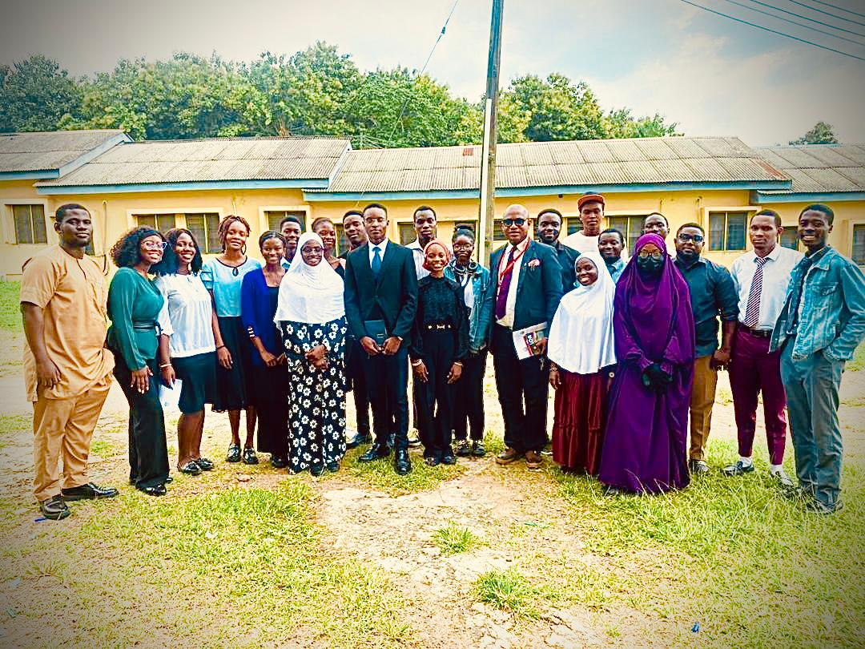

AUGUST, 2025:

Social Committee Creation: This team serves as the driving force behind planning, coordination, and execution of social events. The committee is made up of creative members who share a passion for promoting community spirit.
OSUMSA Fundraising Committee Creation: Following the approval by the House, plans were set in motion towards establishment of the OSUMSA Fundraising Committee. Applications were opened to Osumsites across all levels, resulting in the selection of 10 committed members representing both preclinical and clinical arms of the association. The Committee boasts of a database of 60+ potential sponsors and donors (and expanding) and also a working plan for periodic fundraising drives and brand collaborations.

Proteou Class Hangout – A relaxed and enjoyable event that provided members of the Proteou class with an opportunity to unwind, connect, and strengthen interpersonal relationships after their promotional exams.

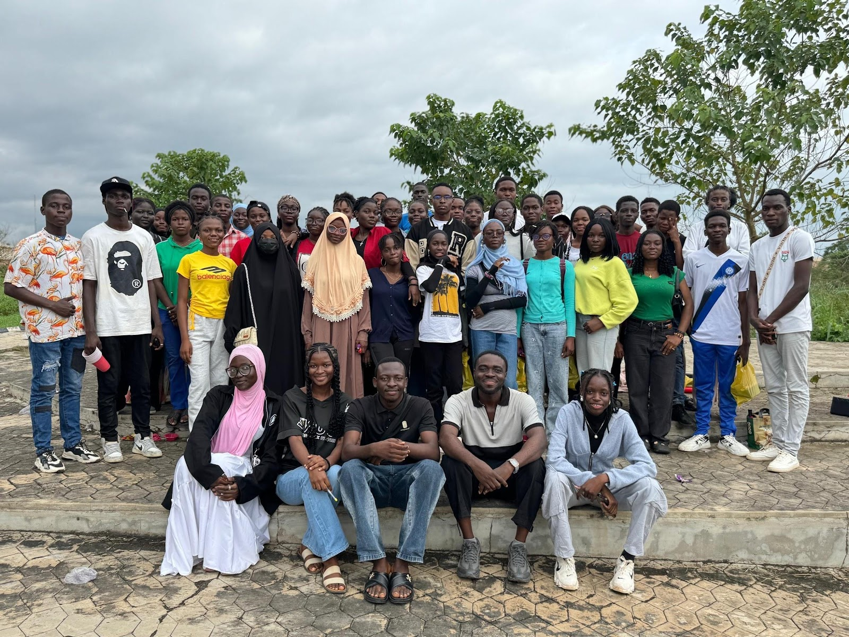

OSUMSA FPL — The OSUMSA Fantasy Premier League (FPL) kicked off in August, featuring three separate leagues. With amazing prizes up for grabs, the competition has brought about a sense of camaraderie, teamwork, and fun among participants. The league has been a success, providing a platform for Osumsites to bond over their shared love of football.

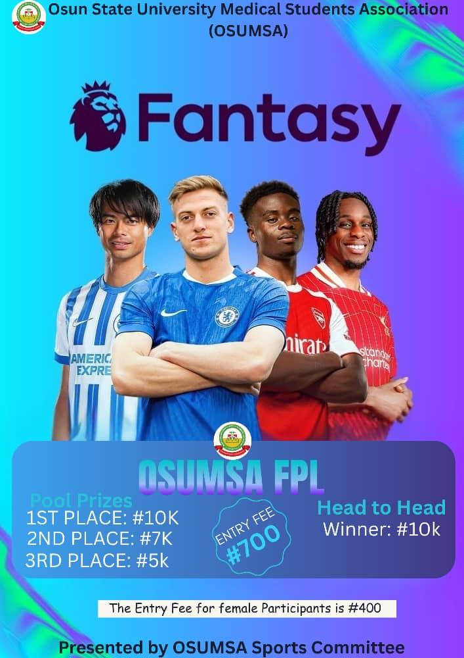

Friendly Matches:
A series of thrilling friendly matches was organized. It served as an excellent platform for Osumsites to showcase their skills on the pitch and on the court. Notable matches included friendly football encounters against the Osun State College of Nursing and a friendly basketball match Osun State College of Nursing. These matches fostered team spirit and further solidified inter-school relationships.

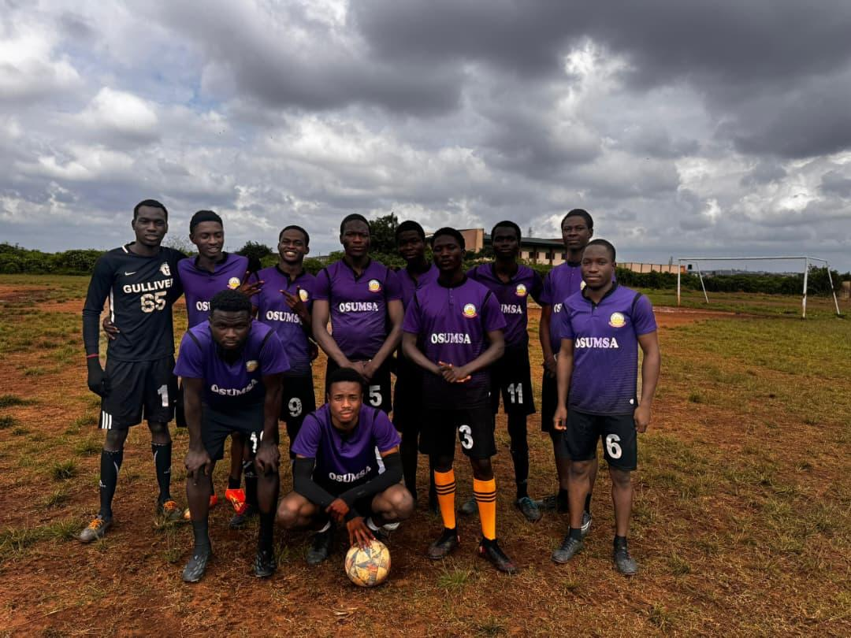

Coverage of the OSUMSA vs OSCON Football Match: Full media coverage of the friendly football match between OSUMSA and OSCON, held at the Technical College. The match was streamed live on the association's Instagram page, with real-time updates posted on the X page (Twitter), and engaging highlights shared across WhatsApp groups throughout the game to ensure maximum member involvement.

Sports Quiz: In a stunning display of sports knowledge, the OSUMSA contingent participating in the inaugural sports quiz hosted by NIMSA South West demonstrated exceptional skill. After a fiercely contested competition, OSUMSA emerged as first runner-up.
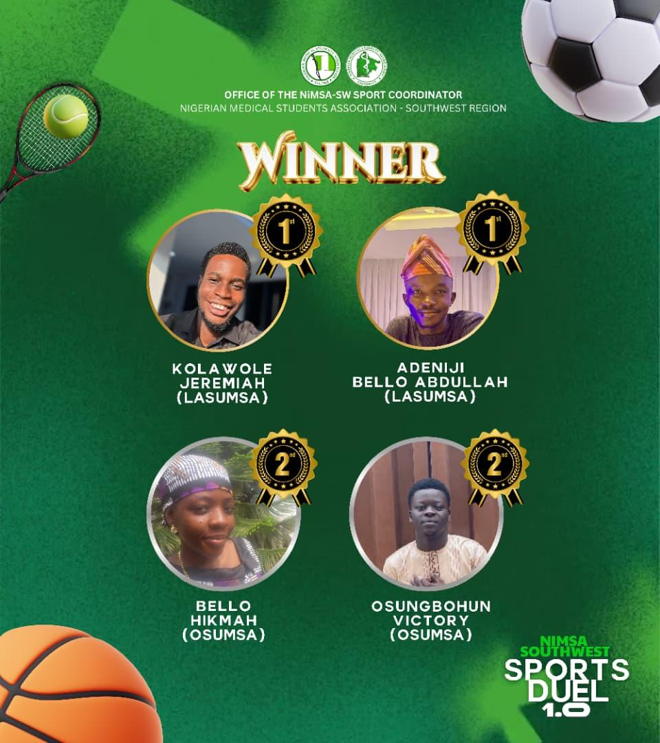

Launch of Mentor-Mentee Initiative: The initiative has been launched, and pairing between senior and junior colleagues is currently ongoing. The aim is to foster seamless communication, mentorship, and knowledge exchange - promoting growth in both academic pursuits and career development for mentees under the guidance of their mentors.

Class Visit I - The Exemplar Executives paid a visit to the Evgenis Giaitroi Class ahead of their upcoming Comprehensive Examinations. The session focused on exam preparation strategies, effective study habits, and time management techniques. Students were also given practical exam tips and insights from past experiences to help them approach the examination with confidence.

Online Mock Examination for 200-Level Students: To further enhance preparedness, an online mock examination was conducted in the form of a quiz. This initiative served as both a practice platform and self-assessment tool, helping students familiarize themselves with exam-style questions, gauge their level of preparedness, and identify areas requiring improvement.

Courtesy Visit I - The Exemplar Executives paid a courtesy visit to the Sub-Dean of the College of Health Sciences, Dr. Aderemi - a medical doctor and lecturer in the Department of Biochemistry. He warmly received the Executives, offering insightful words of encouragement and valuable advice on leadership and academic excellence.

NiMSA Southwest Caucus Meeting - Delegates from the Exemplar Executives - including the President, Vice President, General Secretary, Academic Director, and Financial Secretary - attended the Southwest Caucus Meeting held at the University of Medical Sciences (UNIMED), Ondo State.

The meeting featured inter-MSA networking and deliberations on matters affecting the Southwest region. During the session, OSUMSA formally declared its interest in the NiMSA Presidency, reaffirming its commitment to strengthening its national presence and contributing meaningfully to the Nigerian Medical Students’ Association.

Creation of the OSUMSA Content Creation Team:
A dedicated sub-team was created under the Office of the Public Relations to handle designs, captions, and content planning for OSUMSA publicity. This has improved the quality and consistency of media output.

Purchase of a Content Microphone:
To improve audio quality for video content, interviews, and event coverage, the office acquired a content microphone. This investment has enhanced professionalism and made media production more efficient.

Integration into the NIMSA Southwest PRO HUB:
The Office of the Public Relations joined and actively participated in the NIMSA Southwest PRO HUB platform to ensure that all relevant information and updates from the zonal body reach OSUMSA members promptly.

SEPTEMBER 2025

Launch of OSUMSA Global MedLink: A Premier Opportunity Hub has been launched to connect medical students with diverse growth avenues - including fellowships, scholarships, conferences, online courses and certifications, as well as career development and leadership programs.

This initiative reflects our commitment to nurturing well-rounded future doctors by equipping them with the knowledge, skills, networks, global exposure, and personal development essential to thrive in medicine and beyond.

Distribution of Motivational Welfare Packages: Customized welfare packages were procured and distributed to every individual in both the EVGENIS class. The welfare package included: Pen and Pencils and Emotional Support via motivational quotes. This initiative successfully provided both practical assistance and emotional upliftment
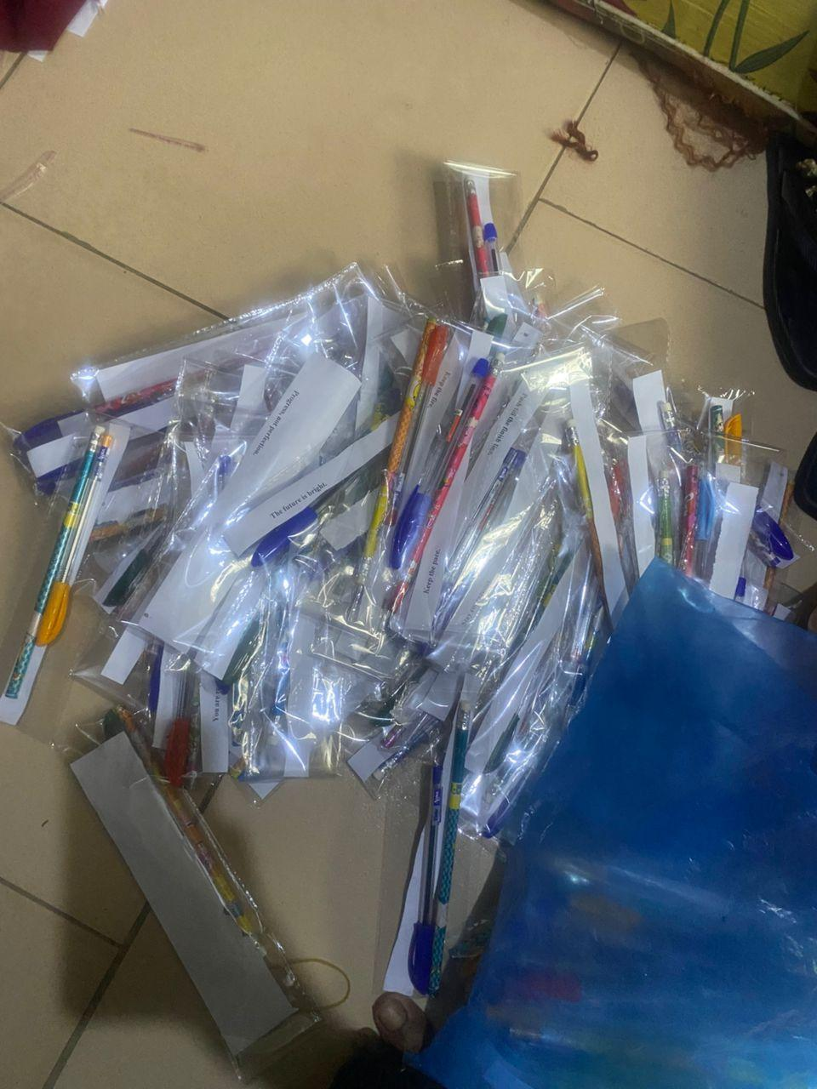

Class Visit II: The Exemplars Administration paid a class visit to the Ikanoi Giaitroi Class ahead of their upcoming MB I Examinations. The session was highly productive and interactive, focusing on preparation strategies and encouragement as the students approach their first professional medical board exams.

Mock MB I Exams: A physical mock examination and orientation session were organized for 300-level students ahead of their MB Examination. This aimed to simulate the actual exam environment, reduce anxiety, and promote effective revision strategies. During the orientation, discussions also covered academic discipline, stress management, and peer collaboration, which contributed to the overall success of the exercise.

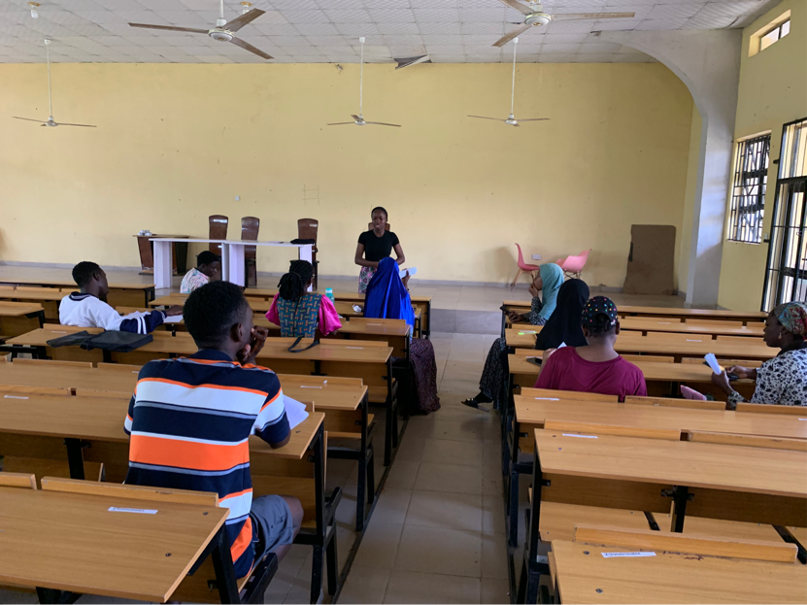
Academic Support for Students with challenges: The Office reached out to students who had resits or repeats in the Comprehensive Examination. This provided academic guidance, encouragement, and moral support, helping them reflect on their performance and prepare more effectively for their next attempt.
Establishment of the PRO-Class Reps Group: A structured communication channel was developed between the PR Office and class representatives to ensure smooth and effective information dissemination for all association events and announcements.

Friendly Match: A friendly match with NMA Osogbo was organized. This fostered team spirit.

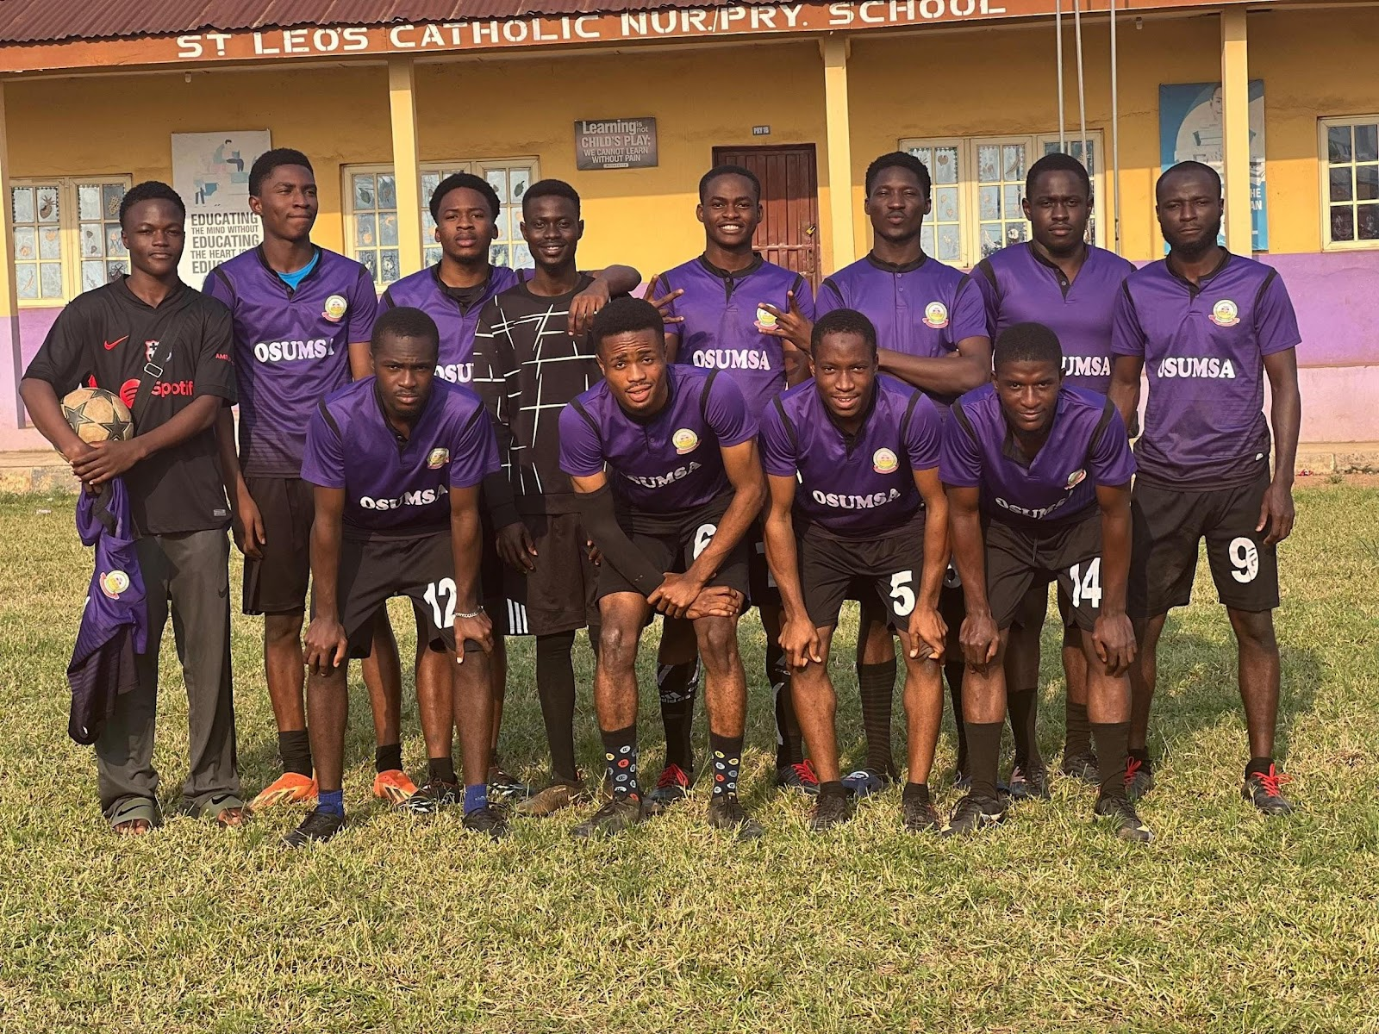

OCTOBER 2025
CAPACITY BUILDING I:
The Capacity Building Series, launched on October 25th, 2025, was designed to empower medical students with soft and professional skills beyond the classroom. 100+ registrations from Osumsites and non-Osumsites across different universities. Over 50 active participants attended the virtual session.

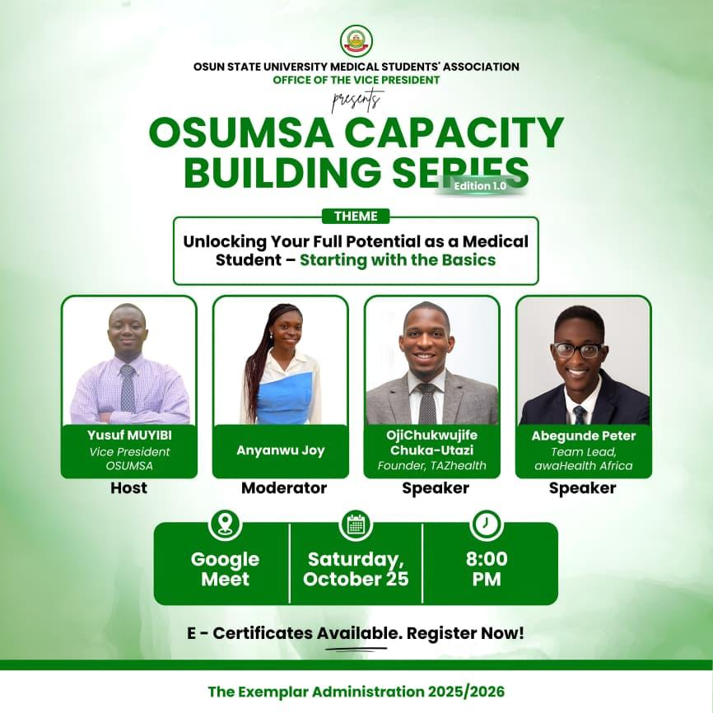

COURTESY VISIT II: The Exemplars Administration paid a courtesy visit to the Medical and Dental Consultants Association of Nigeria (MDCAN), UTH Chapter. The meeting was productive and insightful, as the Executives received words of encouragement and a firm assurance of continued support and mentorship from MDCAN.
IKANOI Hangout & Games: Another successful social engagement that brought the Ikanoi class together in a fun, inclusive environment. This hangout helped them to unwind after a full month of intensive exams.
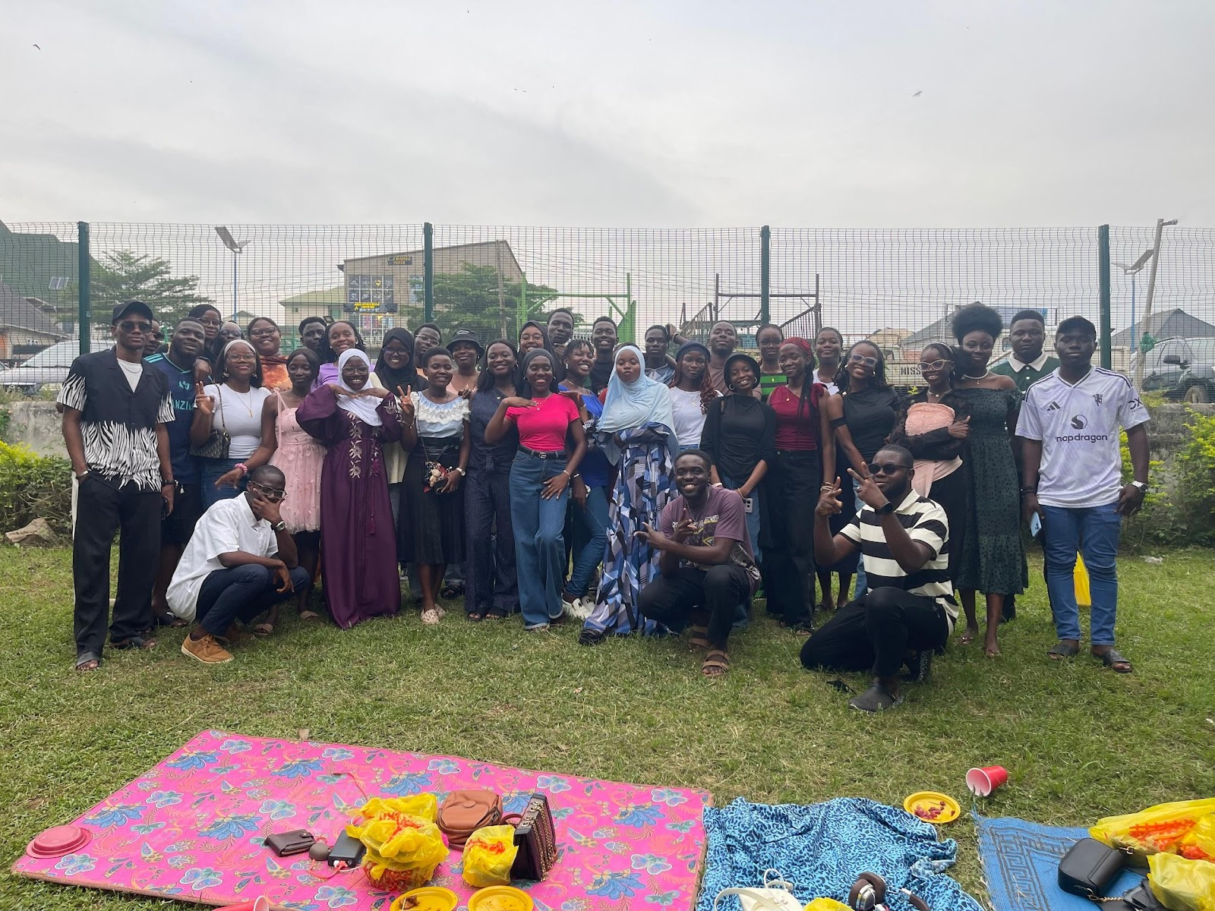
NiMSA Southwest Convention: Previously scheduled for September, the convention held in the heart of Lagos at the Lagos State University College of Medicine (LASUCOM), Ikeja. The event featured a variety of activities, including quiz competitions, debates, sports, a dinner, and a caucus meeting. OSUMSA was ably represented by nine delegates, making it a valuable opportunity to connect with medical students across Southwest schools, unwind, and engage in meaningful learning experiences.

Distribution of Motivational Welfare Packages
Customized welfare packages were procured and distributed to every individual in both the EVGENIS and IKANOI classes. The welfare package included: Pen and Pencils and Emotional Support via motivational quotes. This initiative successfully provided both practical assistance and emotional upliftment 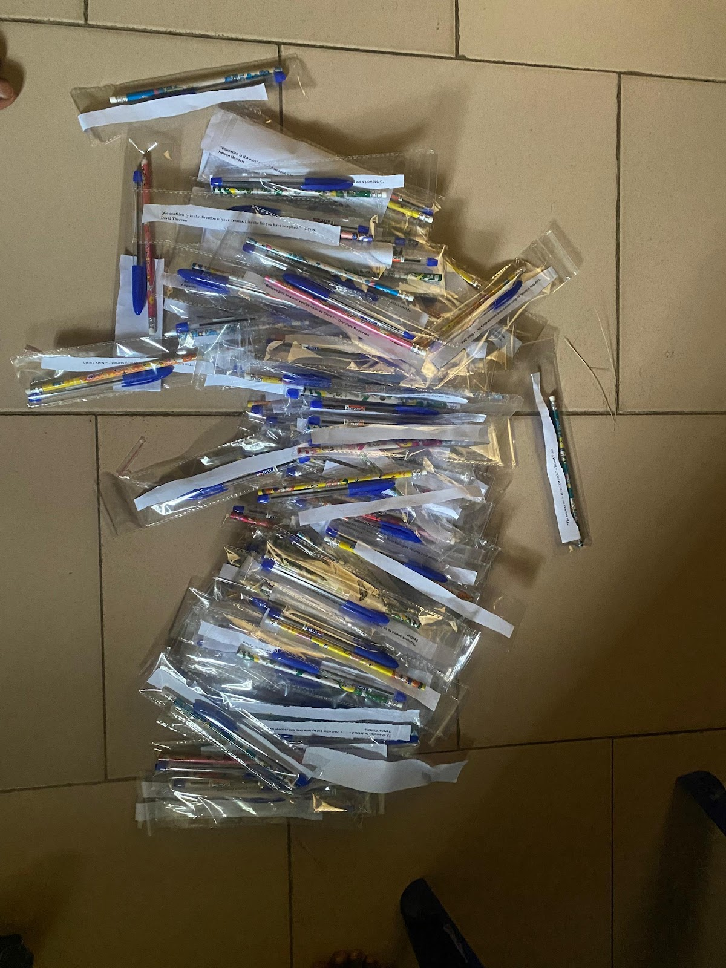
Circulation of Emergency Contact Information:
Recognizing that the safety and security of members is paramount, the Office of Welfare compiled and circulated a list of emergency contacts via welfare committee and the virtual forum.
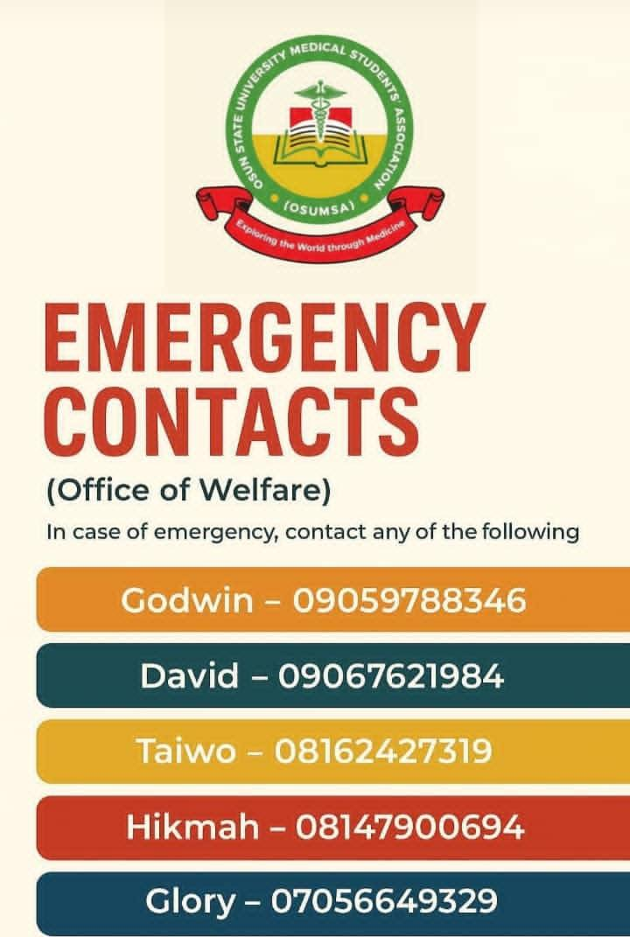

Courtesy visit to the HOD of Accident and Emergency unit of UNIOSUN TEACHING HOSPITAL: The accident and emergency unit is one of the major pillars in the emergency response system service in OSUMSA.
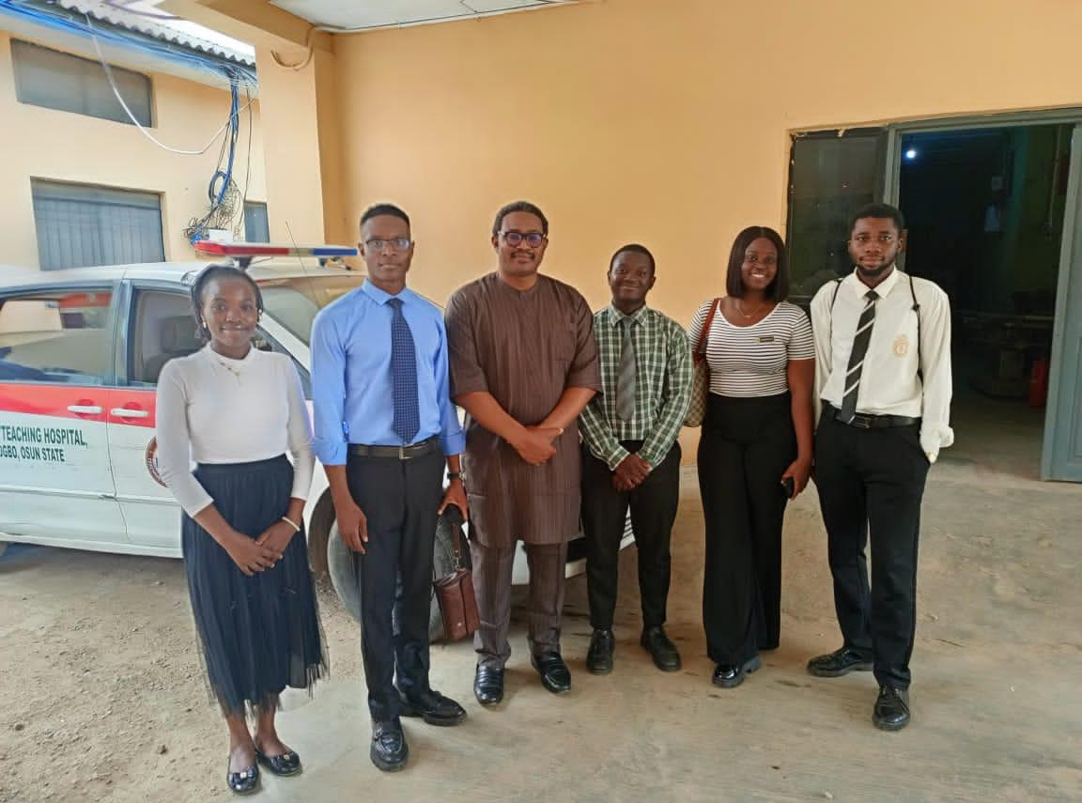
CHANGE OF SIGNATORIES: The mandatory process of the change of signatories have been successfully carried out. Withdrawal from the account after necessary consultations from the executive council and the SRC is henceforth subject to the newest signatories, who are: The President, Financial Secretary and Treasurer.

